Technical Specifications in Formatting Assessment Tools

PAPER AND MARGINS
- Paper: Long (8.5”x13”)
- Margins: 1” in all sides

HEADER AND FOOTER
- Center alignment for both
- Refer to DO 31 S. 2019 for the use of logo and fonts for header. 
- Footer has page number. Font for footer is Century Gothic for Elementary with 12pt font size, and Bookman Old Style for JHS and SHS with 11pt font size.
- Header is for front page only.
- Header height is 0.5” and footer height is 0.3”
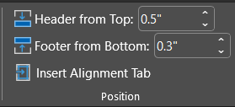

TITLE
- Title is in upper case.
- Alignment is in center.
- For Filipino medium:
- For English medium:
DIRECTIONS
- Texts for directions is in bold format.
- Use appropriate directions/instructions suitable for the test items and learners.
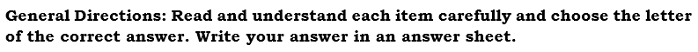
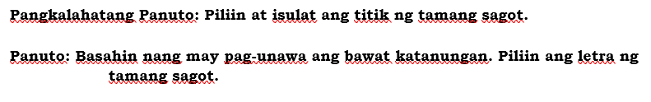
CONTENT
- Use proper font/typeface and font size as follows:
Key Stage | Font/Typeface | Font size
1 | Century Gothic | 12
2 | Century Gothic | 11
3 | Bookman Old Style | 11
4 | Bookman Old Style | 11
- Test items should be aligned in MELC(based from TOS).
- Test items/statements are justified in alignment.
- Set one space before and after each test items and paragraphs.
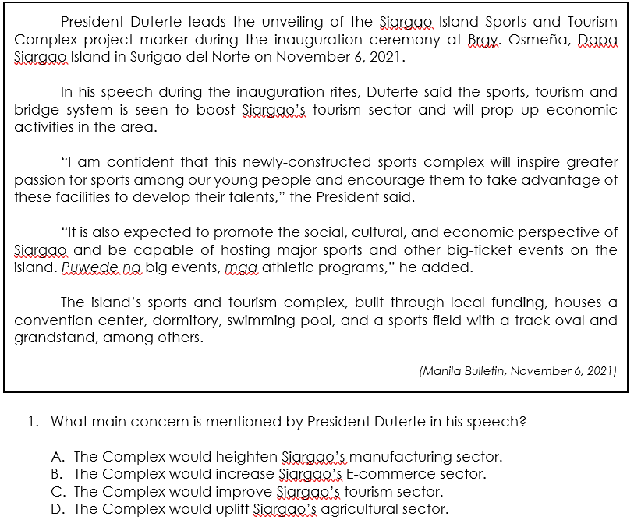
ILLUSTRATIONS/REPRESENTATIONS
- Illustrations/representations are center aligned.
- They should be visible especially if it has labels.
- Use colored illustrations/representations if test items requires.
- Avoid using illustrations/representations with too much details as it may blur during reproduction.
- It is should be in line with text.
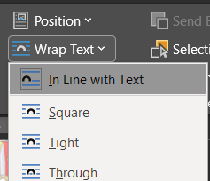
- Set the font size of caption to 9”.
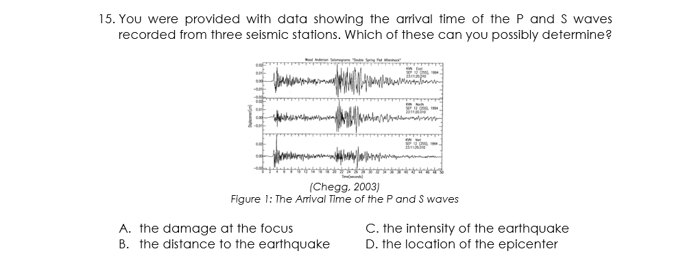
TEST CHOICES
- Letter of choices is in UPPER CASE.
- Indention is 0.5”.
- If choices are short:
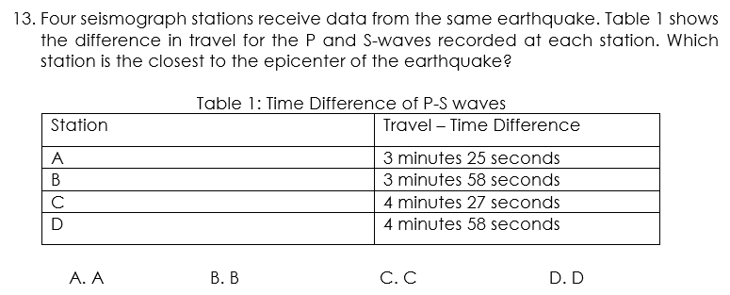
- If choices are words/phrases that can be fit for two columns:
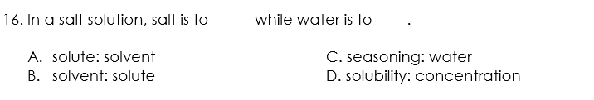
- If choices are long:
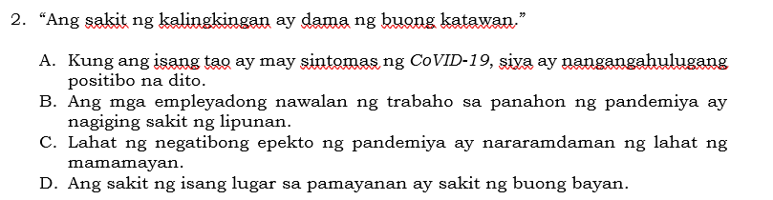

- If choices are two or more:
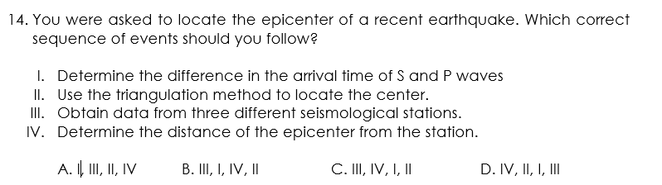
STYLE GUIDES AND SOCIAL CONTENT GUIDELINES
For style guides and social content guidelines refer to the following DepEd prescribed manuals.
- DepEd Manual of Style
- Ortograpiyang Pambansa 2014 Edition
- Manwal sa Masinop na Pagsulat

